Database Management– BUSA 526
Midterm exam

Instructions
- Please upload your MS-Word document (only one document) and MySQL script to Blackboard.
- When submitting the assignment document please save the document using the following format (last first name BUSA 526 MTE Spring 2025). For example, if I was submitting the assignment then the document should be saved as Kumar Anil BUSA 526 MTE Spring 2025.
- All submissions are to be typed using Times New Roman, font size 12 and single-spaced.
- This exam is due on March 9, 2025, by 11:59 p.m.

Guidelines
- The exam should be well organized, logical, and clear.
- This is a professional document, and you need to make sure you have checked your document for spellings and grammar before submitting it.
- You need to answer all the questions.
- Make sure you read the questions carefully before answering them.
- Focus on providing insights and answering in your own words.

Plagiarism declaration:
- I know that plagiarism is wrong and will result in an automatic fail. Plagiarism is to use another’s work and pretend that it is one’s own.
- I did not copy anyone’s work and did not share our document with any other group.
- I am aware of the university academic integrity policy. (https://www.tamuc.edu/college-of-business/integrity-policy/).

Your Name: Mika Kouakou

Q#1 (50 points): This question is based on the concept of the power of data in the real world.

News Article Selection:
- Title: The Rise in Remote Work Since the Pandemic and Its Impact on Productivity
- Authors: Sabrina Wulff Pabilonia and Jill Janocha Redmond
- Source: U.S. Bureau of Labor Statistics (BLS)
- Published Date: Thursday, October 31,2024
- URL: https://www.bls.gov/opub/btn/volume-13/remote-work-productivity.htm
Problem Framing (Data Perspective):
In this article we dive into the depths of a social issue, “The rise in remote work since the pandemic has impacted employee productivity”. The data presented in this article shows that some industries report higher efficiency, while others face collaboration challenges. In fact, Businesses face with the problem of “quantifying” productivity accurately, sparking debates on remote vs. in-office performance. We can use data insights such as job satisfactions surveys to help with the analysis and optimization of the company’s efficiency.
How does remote work impact employee productivity, and what data-driven insights can organizations use to optimize work performance in remote versus in-office settings?

Entity-Relationship Diagram (ERD):
The ERD for Remote Work vs. In-Office Productivity models are key factors affecting employee performance. A central Employee entity, 1:M associated with Task and Meeting to watch work output and study the cooperation of people. Work Environment, 1:1 linked to Employee, gives us measures of internet quality and the degree of distraction at one specific location, such data being essential when comparing remote to in-office conditions.
Such a structure also means that data on trends in productivity can be used for organizational analysis, and thus linked up with workflow improvements encapsulating our key question:

"How does remote work impact employee productivity, and what insights can organizations use to optimize performance?"

This ERD makes management of data effective and means that comparisons can be made as far as judgments on decisions.
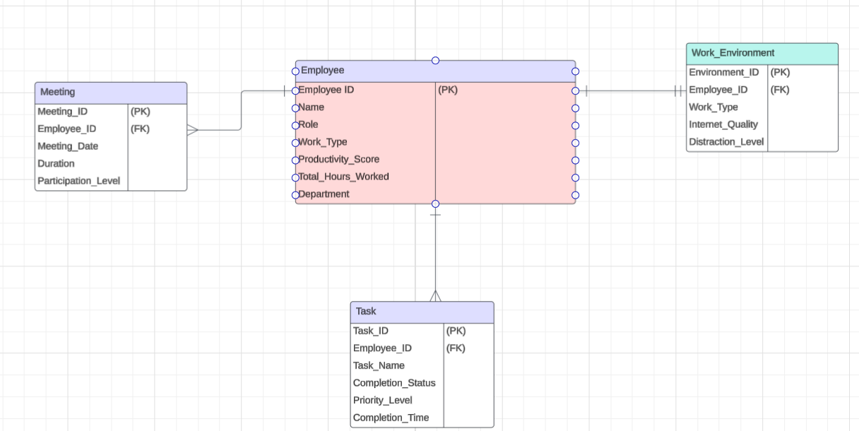
Entity-Relationship Diagram (ERD) for Remote Work vs. In-Office Productivity

Data Analysis Considerations:
The Entity-Relationship Diagram (ERD) comparing Remote Work and In-Office Productivity offers a systematic framework for evaluating employee performance, collaboration, and working conditions. By tracking key entities like Employee, Task, Meeting, and Work Environment, organizations can compare productivity trends between remote and in-office workers. Two examples of data analysis that would be relevant to these ERDs would be:
- Descriptive analytics which can summarize average productivity scores, helping businesses figure out whether remote or in-office employees perform better.
- Trend analysis can monitor task completion rates and meeting attendance over time, revealing trends in efficiency and collaboration.
The relationships between these entities would be crucial for our analysis. In fact, the 1:M relationship between Employee and Task indicates work efficiency, while the 1:M association between Employee and Meeting assesses the influence of collaboration on productivity. The 1:1 relationship between Employee and Work Environment links work conditions, including internet reliability and levels of distraction, to performance results.
However, this analysis encounters challenges related to data quality, such as gaps from incomplete task tracking, inconsistent assessments of productivity, and privacy issues associated with monitoring employee performance. If these problems are addressed, more accurate outlooks make it possible for remote work as well as hybrids to be optimized.

Thought Process:
I used the concepts learnt in our modules such as “System Thinking” which helped having an idea of the type of interconnections existing between the entities(employees, tasks, meetings, and work environments), through the application of “data modeling” I have created and design ERDs illustrating the cardinality 1:M and 1:1 relationships, ensuring clear connections between productivity factors, by applying normalization, I was able to eliminate redundancy in the data by storing work conditions in a different table. In this way data duplication was made impossible. An example of challenges that might arise when working with this data are missing task records and inconsistent productivity metrics, while ensuring accurate and structured data collection to support meaningful analysis. This analysis can provide a scalable framework for enhancing workforce efficiency.

Q#2 (40 points): Ramuk Bakery Scenario

- To improve bakery operations, Ramuk should collect and analyze the following data:

- Customer Orders:

Attributes: Order ID, Customer ID, Product ID, Order Date, Pickup Date, Status (Completed, Delayed, Canceled).

Benefit: Analyzing order fulfillment times and identifying patterns in delays can help improve scheduling and inventory management.

- Inventory Levels:

Attributes: Ingredient ID, Ingredient Name, Current Stock Level, Reorder Level, Supplier ID.

Benefit: Monitoring inventory levels can prevent stockouts and help in planning orders with suppliers more effectively.

- Supplier Performance:

Attributes: Supplier ID, Supplier Name, Average Lead Time, Order History, Complaints.

Benefit: Understanding supplier reliability can help Ramuk negotiate better terms and improve order planning.

- Customer Feedback:

Attributes: Feedback ID, Customer ID, Order ID, Feedback Type (Email, In-store, Phone), Comments, Resolution Status.

Benefit: Analyzing feedback can identify common issues and areas for improvement in customer service and product quality.

- Sales Data:

Attributes: Sales ID, Product ID, Sale Date, Quantity Sold, Revenue.

Benefit: Analyzing sales trends can help in forecasting demand and adjusting production schedules accordingly.

- The Entity-Relationship Diagram (ERD) for Ramuk Bakery functions as a foundational framework for organizing the database, promoting both efficiency and scalability. It outlines essential entities such as Customer, Order, Product, Supplier, and Inventory, along with their interrelations, including (1:M) and (M:M) connections, to maintain data integrity. By normalizing data, users can minimize redundancy in their storage and be better equipped for queries. The ERD helps to efficiently process sales statistics, stock levels, and customer comments, supporting decision-making and reporting functions. Finally, it guarantees scalability, streamlines the selection of a Database Management System (DBMS), and acts as a visual tool for stakeholders, assisting in development and future growth.
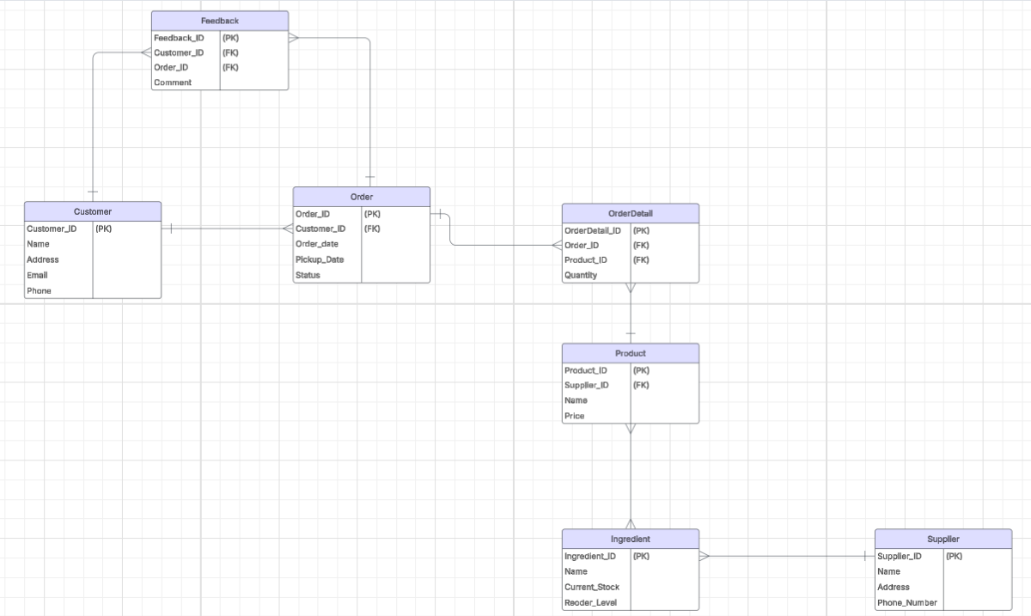
Entity-Relationship Diagram (ERD) for Ramuk Bakery

- The creation of the tables for Ramuk Bakery involved designing a comprehensive schema with tables for Customer, Supplier, Ingredient, Product, BakeryOrder, OrderDetail, and Feedback. Each table was defined with appropriate columns and data types, ensuring foreign key relationships for data integrity. After creating the tables, I populated them with sample data that I asked ChatGPT to help me with generating these data, then used “INSERT” statements. Indeed, during this process, I encountered challenges such as duplicate entries, or forgetting to ensure that the tables were stored in a newly created database, and existing tables, which I resolved by checking existing data with SELECT statements and using “SHOW TABLES” to verify table existence. To streamline data insertion, I implemented “AUTO_INCREMENT” for primary keys.

- According to our analysis of sales trends and customer satisfaction reports, product and customer experiences are very important questions where intelligence is key information for decision-making. With these SQL queries, I compiled sales data categorized by product and computed average satisfaction scores derived from customer feedback. This facilitated the identification of top-selling products and highlighted areas where customer service could be improved. The analysis of sales trends and customer satisfaction reports was necessary to comprehend product performance and customer experience, which are critical for effective business strategies. Finally, I applied SQL queries to aggregate sales data, concentrating on total units sold and overall sales figures for each product, while also determining average satisfaction scores based on customer feedback. This strategy allowed me to identify the leading products and recognize opportunities for enhancing customer service, thereby aligning with the bakery's operational and strategic objectives.

Q#3 (10 points):

While I was working at Bicester Collection, my responsibility was to process company order invoices. I was initially thinking that the delay processing payments was due to inefficiencies within our finance department team. However, with time, I realized that the problem was coming from invoices not properly entered into the JDE Oracle system or that there were investigations going on our side to figure out how much of the prorated amount we were responsible for approving the payment for. Using “systems thinking,” I could have charted the invoice workflow and utilized “data modeling” to establish a more organized process. Taking concepts from ERD and employing them to create a database that would have monitored invoice statuses, approval timelines, and payment schedules. Through “descriptive analytics”, I would have identified frequent delays in invoice approvals, while “trend analysis” would have revealed patterns associated with late payments. Finally, by employing techniques of database management that we have learnt from the modules, I would have been able to speed up the invoice process and enhance relationships with our suppliers at the same time resulting in better performance processing invoice payments and leading to more efficient business operations.

